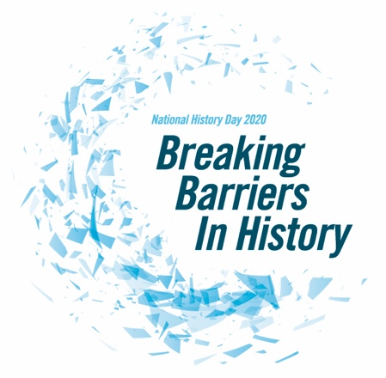
History Day Topic Sheet 2019-2020

DUE:
My topic is:

This correlates with this year’s theme, Breaking Barriers in History, because:
My partners are:

Parent approval

I, ____________________________________________________________ give my permission that my son/daughter ______________________ is allowed to do their History Day project on the topic stated above.

Teacher’s approval _________________________________________________
A copy of this will be kept on file.

