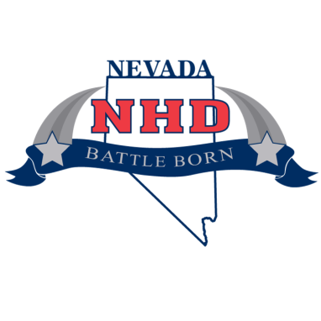

National History Day in Nevada

School Contest Form

School:
Participating Teachers:  Please indicate with an * which teacher in your school will be the main contact for this year’s History Day Program | - _______________________________  - _______________________________  - _______________________________  - _______________________________  - _______________________________  - _______________________________
Dates of Contests:  - Classroom Contests by teacher  Please keep in same order as above  - School Contests  - Registration for State Contest  - State Contest  - National Contest | - _______________________________  - _______________________________  - _______________________________  - _______________________________  - _______________________________  - _______________________________  - _______________________________  - February 28, 2015, Online  - March 14, 2015, UNR or UNLV  - June14-18, 2015 College Park, Maryland

Please complete this and email it to
Emily Rodriquez
erodriquez@interact.ccsd.net

